Mission Day
By Reception
“I have come that they should have life and have it to the full…” (John 10:10)
Inspired by the teachings of Christ, St Edmunds and St Thomas’ Catholic Primary School encourages and guides our pupils and all our school community to have a strong sense of service, love and compassion.
Reception explored what love meant to them.
We planted new life!

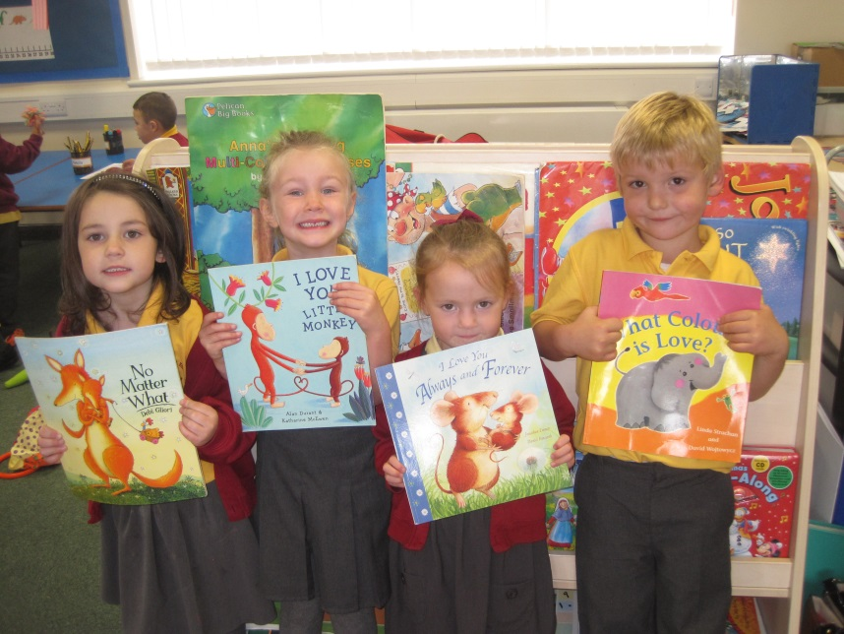
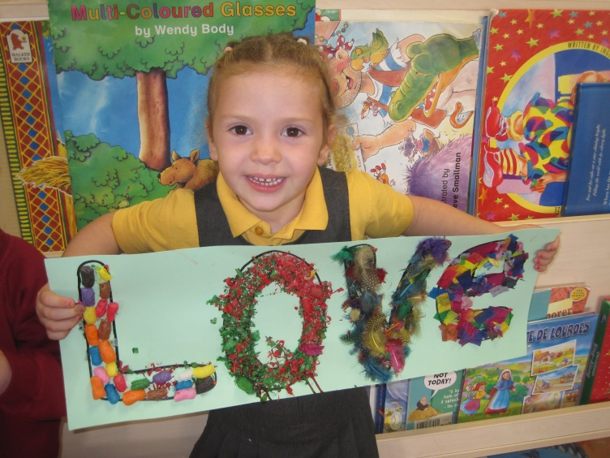
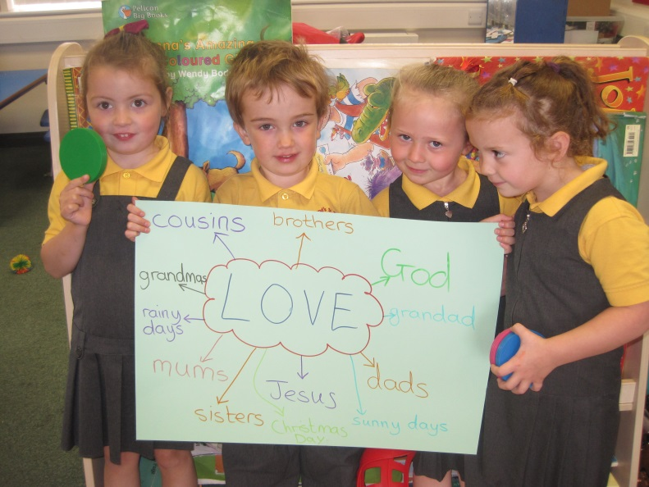
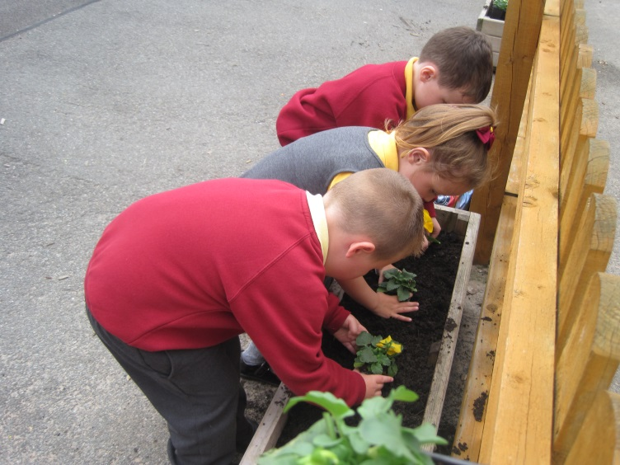
We read stories entitled, What colour is Love? By Linda Strachan, I Love You Little Monkey by Alan Durant, No Matter What by Debi Gliori and I Love You Always and Forever by Jonathan Emmett.
We made a collage of our chosen word.

