It was a sunny day so Reception decided to go for a walk.

When the children got to the pelican crossing, they remembered to press the button and wait for the green man before they crossed the road.

They walked down the path

and past the supermarket.

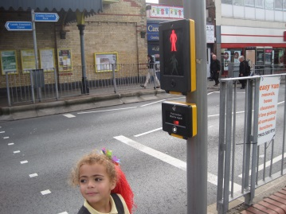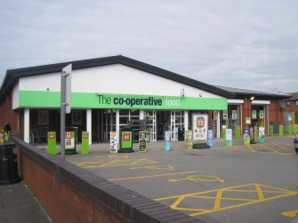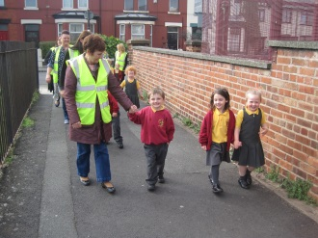

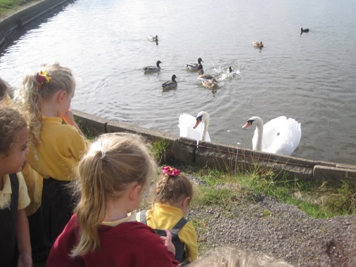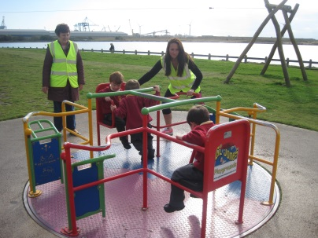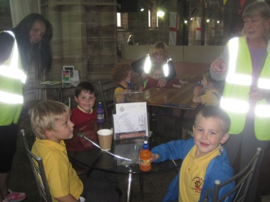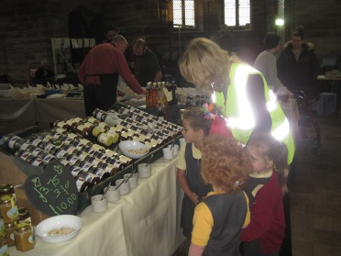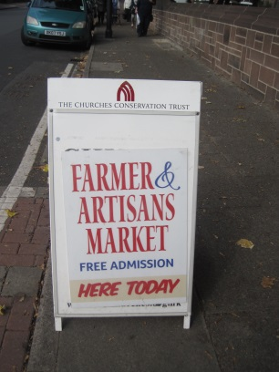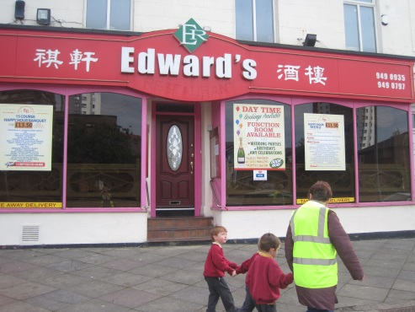

They walked past St Thomas’ church,

Then it was time to go back to school. Everyone had a great day.

Even the swans and ducks came to say hello.

Freddy’s mum was very good at pushing the roundabout!

It was such a lovely day that the children decided to stop at the park.

Frankie’s Nan bought everyone a juice because they had all been very well behaved. Everyone remembered to say thank you.

There were lots of different kinds of tasty food. Ms Bowden bought some for snack. She bought cheese, honey and jam. Yum yum.

The farmer’s market looked interesting so they decided to go in and have a look.

and the Chinese restaurant.