Reception and Year One Sponsored Welly Walk
Thank you to everyone who helped to sponsor our Welly Walk.
It was a great success; even the sun came out to join us!
YOU helped raise £576.
We will keep you informed about what we do with the money.
In the meantime here are some photos from our Welly Walk day.
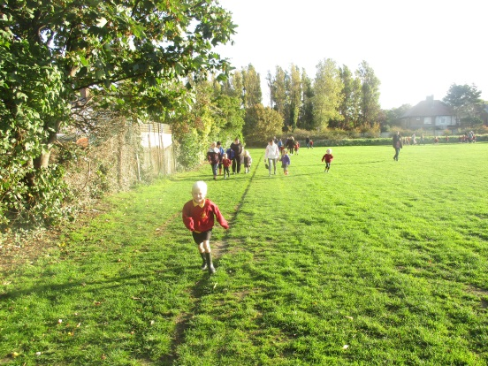
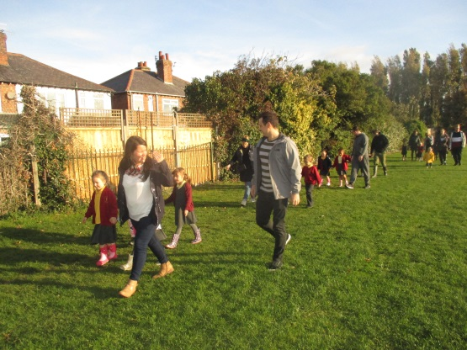
Thank you again for you much valued support.
