

**Saint Edmund’s and Saint Thomas’**

**Catholic Primary School**

**Oxford Road, Waterloo L22 8QF**

**Tel 0151 928 5586 Fax 0151 928 4352**

 

*“Love, Learn and Live Like Jesus*

Dear Parents/Carers,

On **Sunday 1st October** St Edmund’s and St Thomas’- along with Sacred Heart Catholic Academy, Great Crosby Primary and Ursuline Primary- are hosting the **‘Crosby Community 5K Charity Run’**. This event is being held in memory of Isobel Morison, a teacher at Sacred Heart who sadly passed away in 2019.

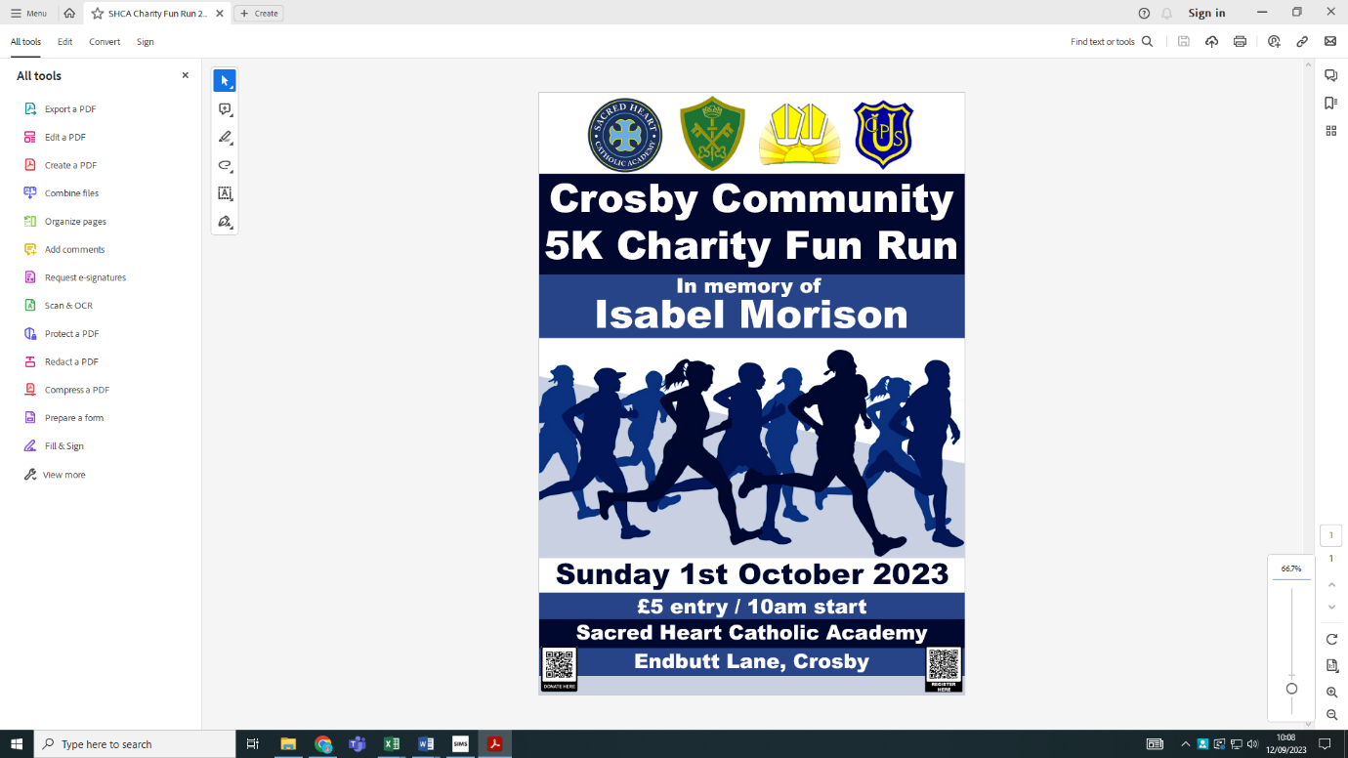We are encouraging all of our Great Crosby families and local community to get involved! The event is open to all ages and all abilities – feel free to walk or run!

The event is being hosted by Sacred Heart Catholic Academy. Both Liverpool Road and Endbutt Lane gates will open at 9.30am and the race will begin from the back field at 10am. The finishing post will be at the front of the school.

After the event, there will be an opportunity to buy food, sweets and ice cream from local businesses. There will also be bouncy castles for the children to burn off any remaining energy!

All money raised from the day will be shared between 4 charities, chosen by the schools.

**The Jacob Billington Trust**

**The Jack Riding Foundation**

**Cafod**

**Claire’s House**

**Mind**

**To register for the 5k, please click this link**  <https://forms.gle/YaLd4u8MJ5aVDZcDA>

**To pay the £5 entry fee, please click here**- <https://gofund.me/0f5ff2ac>

For t-shirts and hoodies, please click this link – <https://www.westcoastworkwear.co.uk/online-store/Sacred-Heart-c153252753>

We hope to see as many of you there as possible. Please invite your friends and wider families – let’s make it a day to remember!

Many thanks

Mrs Claro