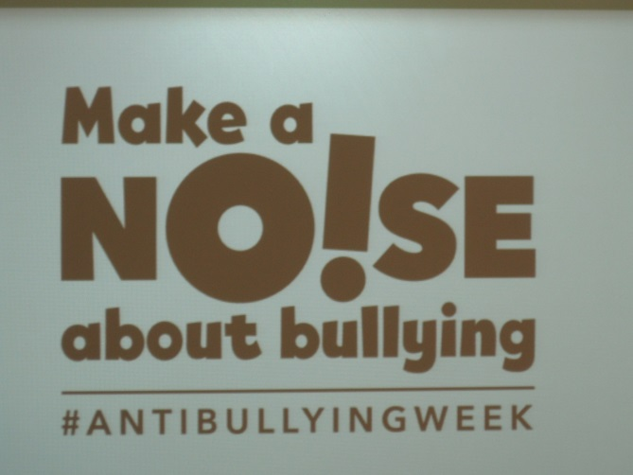

In class 2C we have been completing a number of activities to help us understand what bullying is. We now know that a bully will deliberately hurt someone which is repeated over a period of time. We understand that it is very important to TELL someone, this could be a friend, teacher or even write a note. During the week we role-played and discussed some forms of bullying, produced some lovely posters and poems and made our own bully band.
