Reception’s Autumn Walk

It was a lovely autumn day so Reception decided to go for a walk.

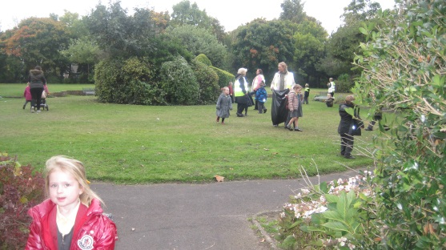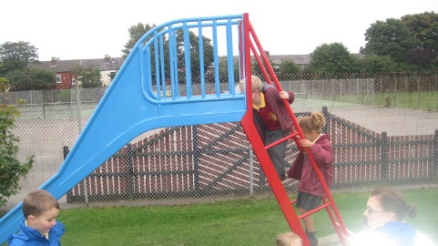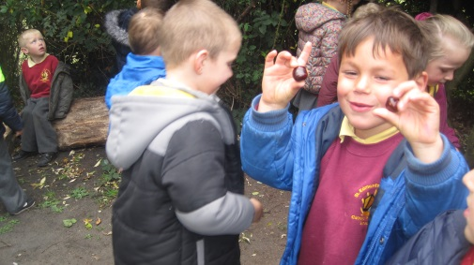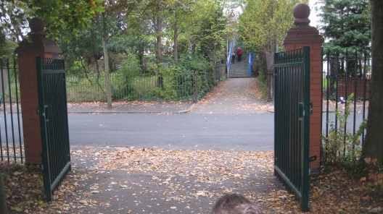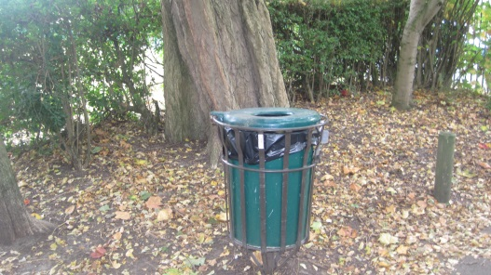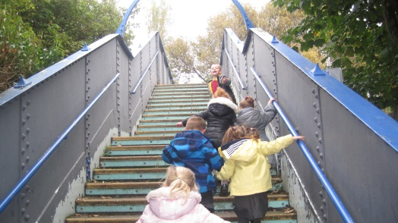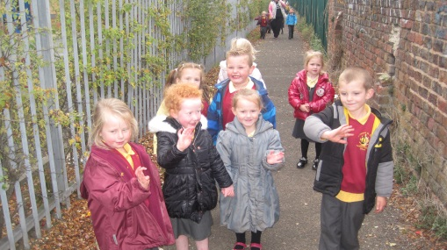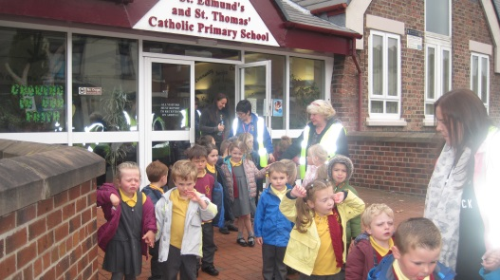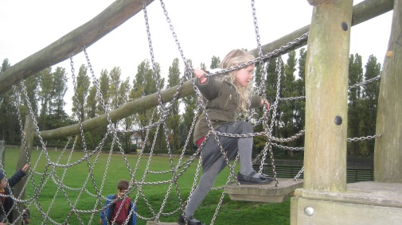

When they arrived at the park everyone looked for signs of autumn. The children collected lots of many different sizes, shapes and wonderfully coloured leaves to take back to class.

Finally it was time to go back to school. Reception enjoyed their walk to the park.

Ms Bowden and Mrs Lennon let us play in the park. We went up and down the slide.

Thomas found conkers!

Past the bin.

Through the park gates.

Over the bridge.

They walked along the footpath.

Across the climbing frame.